Shared Embedding Spaces - Methodology Mapped to Our Actual Tests
Topology, geometry, directions, shared Hub, retrieval, and the Platonic interpretation
Running item used throughout: image = a cat sitting on a chair; text = "A cat is sitting on a chair."
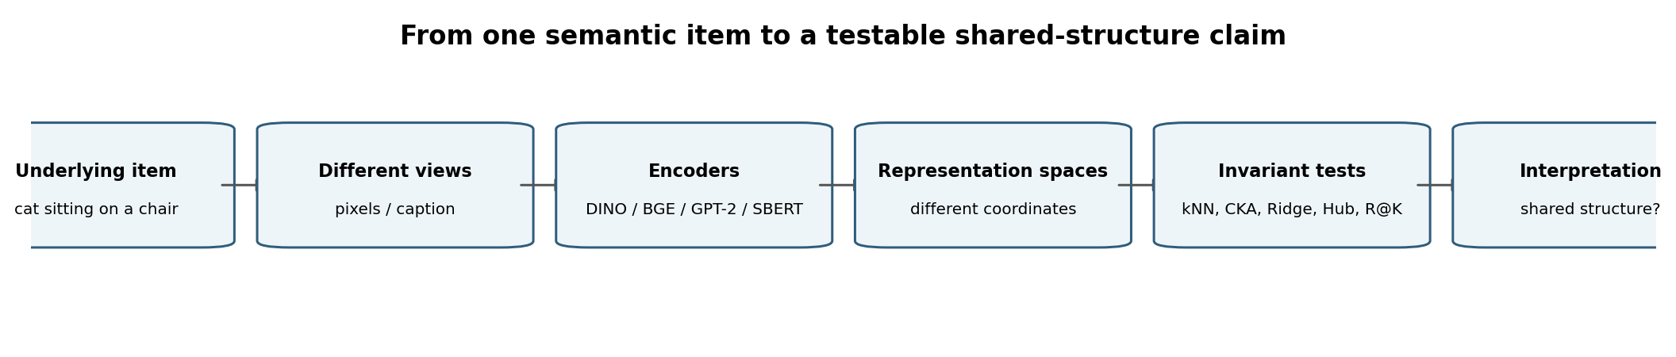
How to read this version
Every methodological concept is now tied to the exact test we performed when the sources support that claim. Where a concept was only proposed as a next experiment, it is explicitly marked PROPOSED rather than silently presented as completed.

1. Test-to-Concept Assignment Map
Explained item | Project test | Status | Interpretation
Aligned semantic item | G1 row alignment across 9,533 items | PERFORMED | Defines same referent across modalities.
Local topology | kNN / shared-neighbour graph + k-scale vs chance | PERFORMED (recent local-topology test) | Tests who is near whom.
Global structural geometry | CKA matrix | PERFORMED / existing structural test | Tests whole-matrix relational similarity.
Directional export A -> B | Ridge / linear maps; E1 and G1 maps | PERFORMED | Tests whether one coordinate system predicts another.
Shared coordinate space | G1 512-d Hub construction + encoder-to-Hub maps | PERFORMED | Tests a common intermediary language.
Cross-model reuse of shared space | Freeze Hub->BGE head on DINO-small; feed base/large Hub vectors | PERFORMED | Strong functional shared-Hub test; 95.9% / 92.9% of native-head performance.
Exact pair identity | R@1 / R@5 / R@10 retrieval | PERFORMED as operational metric | Tests whether the correct paired target wins among candidates.
Coarse correspondence | Verification AUC | PERFORMED / diagnostic | Tests true-pair distribution vs random-pair distribution.
Usable directions / intrinsic dimensionality | SVD spectrum + effective rank | PERFORMED | GPT-2 effective rank about 6.5/768.
Anisotropy | Mean pair cosine + spectral concentration | PERFORMED diagnostic | GPT-2 mean pair cosine about +0.999.
Hubness | Nearest-neighbour occurrence concentration | DIAGNOSTIC; source explains it but gives no numeric hub-count table | Checks whether a few candidates attract too many queries.
Hub width | HUB_DIM / SVD prefix sweep, retention, rows-per-dim, transfer | METHODOLOGY USED; G1 uses 512 | Tests bottleneck vs underpowered mapping trade-off.
Shared distance ranking | Spearman / rank agreement | PROPOSED NEXT TEST | Not established directly by supplied G1 results.
Near-isometry | PCA + Orthogonal Procrustes | PROPOSED for the 7-space extension | Would test same geometry up to rotation/reflection.
Shared latent linear subspace | CCA spectrum | PROPOSED for the 7-space extension | Would separate shared directions from private information.
Model-induced vs world-induced similarity | Group pairs by modality/architecture/objective | PROPOSED exploratory comparison | Would test whether similarity survives architectural boundaries.

2. Why Local Similarity Is Still Part of the Platonic Hypothesis
The Platonic claim does not need to mean one literal global embedding coordinate system. A more precise version is: different models are different charts of a partially shared relational manifold. What should survive across charts are invariants. Local neighbourhood relations are one such invariant.
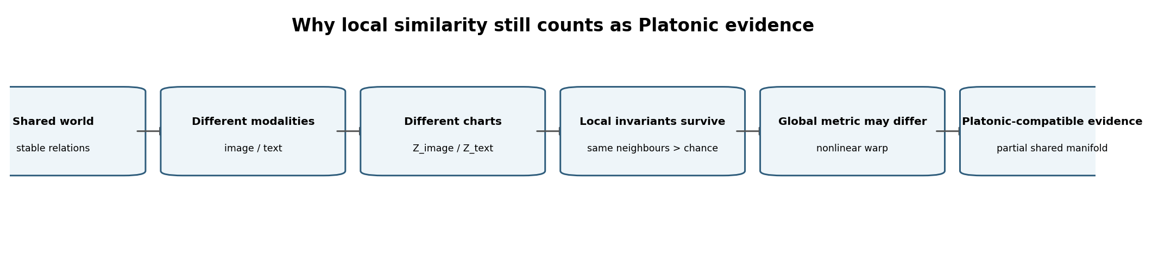
Key distinction
Local topology is weaker than global metric identity, but it is not outside the Platonic idea. A nonlinear coordinate warp can change angles, scales, and long-range distances while preserving which points are neighbours. Therefore local agreement can be evidence for one underlying relational structure viewed through different encoder charts.

For the cat-chair item, the Platonic question is not whether an image vector equals the sentence vector. It is whether both encoders preserve some of the same relations: cat-chair should be near cat-sofa / kitten-on-furniture and far from airplane or unrelated scenes. If this pattern survives across image and text encoders significantly above chance, the common relation is hard to explain as coordinate identity because the coordinates and modalities differ.
What local similarity does NOT prove: it does not prove one global Euclidean metric, one common set of axes, or near-isometry. It supports the weaker statement that part of the relational manifold is shared. That is still Platonic-compatible evidence because the hypothesis is about recovering structure in the world, not about recovering identical vector coordinates.

3. Local Topology - The Test We Actually Ran
STATUS | PERFORMED
TEST USED IN OUR PROJECT | Shared-neighbour / kNN topology test, including scale analysis against chance.
WHAT IT ESTABLISHES | Measures local adjacency: whether the same semantic items are neighbours in two different spaces.
CAT-CHAIR EXAMPLE | Image: cat-on-chair pixels -> img_large. Text: "A cat is sitting on a chair." -> txt_sbert. Compare their neighbour lists.

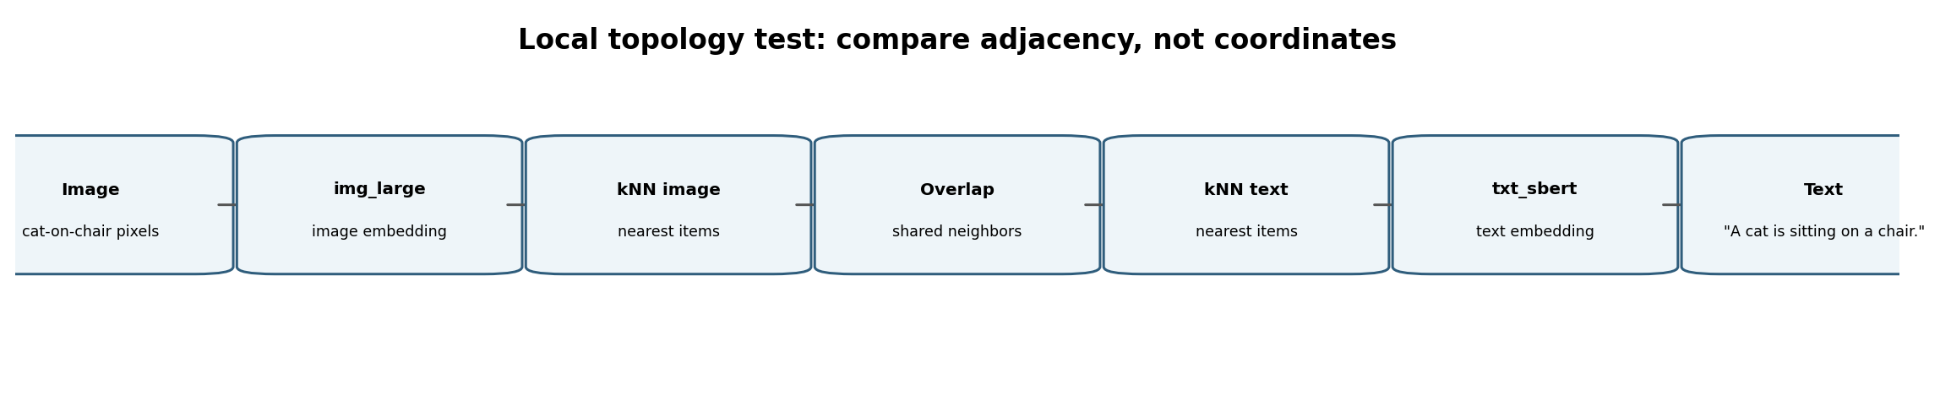
Observed example from the supplied result figure: img_large vs txt_sbert shared 68 of 238 graph edges (29% of the union). The per-item histogram reported a mean of 2.3 agreed neighbours out of 4 possible, with only 3% of items sharing none. The companion k-sweep showed that raw overlap rises with k, but overlap relative to chance falls as k grows. The methodological reading is therefore: the agreement is real but predominantly local.
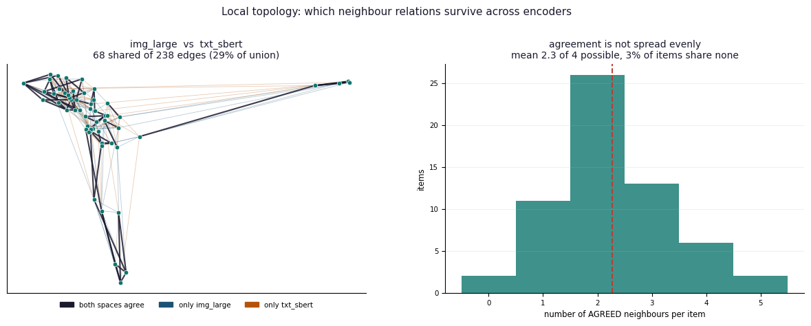
Actual local-topology test result supplied in the conversation.
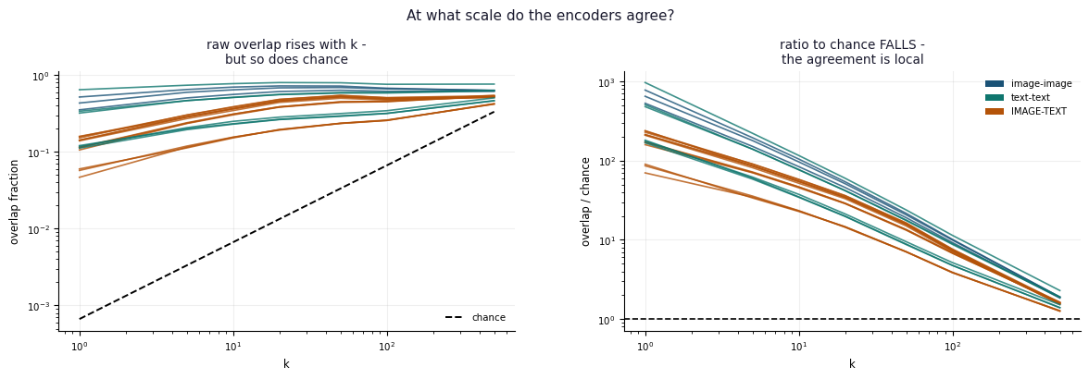
Scale test: raw overlap increases with k, while enrichment over chance decreases.

4. Global Geometry - CKA
STATUS | PERFORMED / EXISTING STRUCTURAL TEST
TEST USED IN OUR PROJECT | CKA matrix across aligned representation matrices.
WHAT IT ESTABLISHES | CKA asks whether the global pattern of pairwise relations is similarly organized even when widths differ. It is symmetric and does not by itself prove exportability.
CAT-CHAIR EXAMPLE | Cat-chair does not need the same vector. CKA asks whether the whole dataset preserves analogous cat/furniture/vehicle relational structure.

Flow: aligned matrices A and B -> center representations -> compute CKA(A,B) -> place score in the 21-pair structural-similarity matrix -> compare local-topology result to CKA. If kNN is high while CKA is lower, the most natural interpretation is shared local topology with a different global metric.

5. Directions - Two Different Meanings and the Tests for Each
The word direction is easy to overload. In this project it should be separated into (a) mapping direction and (b) latent geometric direction.
Meaning | Question | Test | Status | Reading
Mapping direction | A -> B versus B -> A | Ridge / encoder-to-Hub / retrieval | PERFORMED | Asymmetry can reveal information containment or target complexity.
Latent geometric direction | An axis/factor carrying independent signal | SVD / effective rank | PERFORMED | Measures how many useful independent directions really exist.
Shared latent direction | A semantic factor recoverable in both spaces | CCA | PROPOSED | Would explicitly test correlated shared factors.
Same geometry under rotated directions | Axes differ only by rotation/reflection | Orthogonal Procrustes | PROPOSED in 7-space follow-up | Would test near-isometry.

Cat-chair example
Mapping direction: image -> BGE asks whether the image representation can predict a target text-space vector. Latent direction: an SVD component might separate animal scenes from non-animal scenes. Shared latent direction: CCA would ask whether an animal-vs-non-animal factor exists in both the image and text spaces.

6. Direct Exportability - E1 and Ridge Mapping
STATUS | PERFORMED
TEST USED IN OUR PROJECT | E1 direct DINOv2 -> BGE ridge map on aligned image-caption items.
WHAT IT ESTABLISHES | Tests whether one encoder space can be exported directly into another with a single linear transformation. The supplied document reports that five-caption averaging improved held-out R^2 from 0.278 to 0.511; under the matched protocol, the result is 40.9% of ceiling.
CAT-CHAIR EXAMPLE | cat-on-chair image -> DINO vector -> linear W -> predicted BGE vector for the corresponding caption semantics.

Flow: pixels -> DINOv2 embedding x -> W_direct -> predicted BGE vector t_hat -> compare with native BGE target -> evaluate held-out R^2 / cosine / retrieval. This is a directional test: DINO -> BGE is not the same scientific question as BGE -> DINO.

7. Shared Space - G1 512-d Hub
STATUS | PERFORMED
TEST USED IN OUR PROJECT | G1 shared-Hub construction from five aligned spaces, then one encoder-to-Hub map per model.
WHAT IT ESTABLISHES | Tests whether heterogeneous encoders can express the same aligned items in one common coordinate system.
CAT-CHAIR EXAMPLE | The cat-chair item contributes image vectors from DINO small/base/large and caption vectors from BGE/GPT-2; together they define one Hub coordinate h_i.

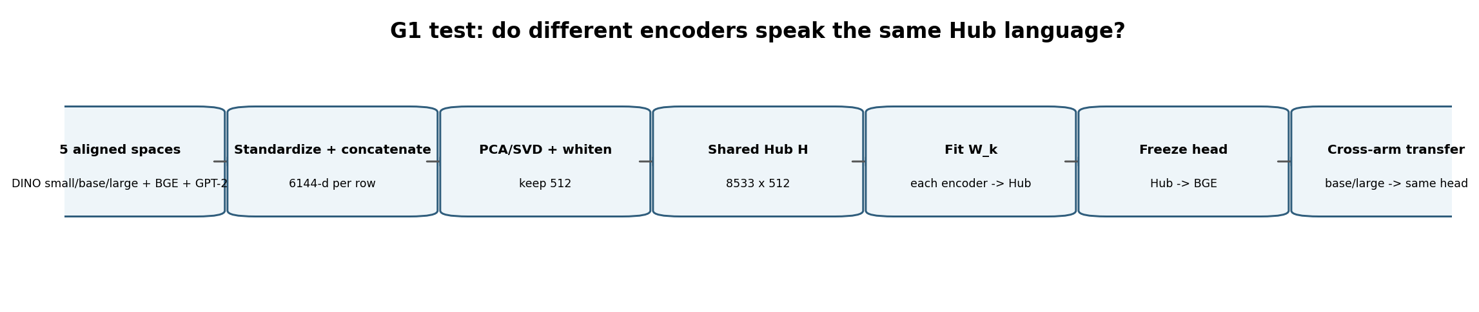
Construction used in the supplied document: standardize each of the five spaces, concatenate widths 768 + 1536 + 2048 + 1024 + 768 = 6144, apply PCA/SVD, keep 512 components, and whiten. This yields H in R^(8533 x 512). Then fit X_k W_k ~= H for each encoder.
Important: shared space is not just a visualization
The strongest G1 test is functional: train the Hub->BGE head using only DINO-small Hub vectors, freeze it, then feed Hub vectors from DINO-base and DINO-large that the head never saw during fitting. The supplied document reports 95.9% and 92.9% of corresponding native-head performance. That is direct evidence that the Hub coordinates have cross-encoder operational meaning.

8. Retrieval and Verification - Strong vs Weak Correspondence Tests
STATUS | PERFORMED
TEST USED IN OUR PROJECT | R@1/R@K retrieval plus Verification AUC.
WHAT IT ESTABLISHES | R@1 asks for exact pair identity among all candidates. AUC asks only whether true pairs tend to score above random pairs.
CAT-CHAIR EXAMPLE | The mapped cat-chair vector may beat most random captions but still lose top-1 to two very similar cat/furniture captions.

Retrieval flow: mapped source -> target-space query vector -> cosine against all candidate target vectors -> rank -> R@1 / R@5 / R@10. Verification flow: score true pairs + random pairs -> ROC/AUC. The pair of tests tells us whether signal is merely present or sharp enough for exact identity.
Interpretation rule
AUC high + R@1 low = coarse correspondence survives, but pair-specific discriminability is insufficient. This is why an R@1 collapse alone cannot prove that shared structure is absent.

9. Geometry Failure Diagnostics - SVD, Effective Rank, Anisotropy, Hubness
STATUS | PERFORMED for effective-rank/anisotropy; HUBNESS is a diagnostic defined in the source without a numeric hub-count table
TEST USED IN OUR PROJECT | SVD spectrum, effective rank, mean pair cosine, nearest-neighbour occurrence concentration.
WHAT IT ESTABLISHES | Distinguishes absence of shared structure from a representation/pipeline that has collapsed discriminative geometry.
CAT-CHAIR EXAMPLE | If many captions all point in nearly the same direction, the true cat-chair caption may have high cosine but little margin over wrong captions.

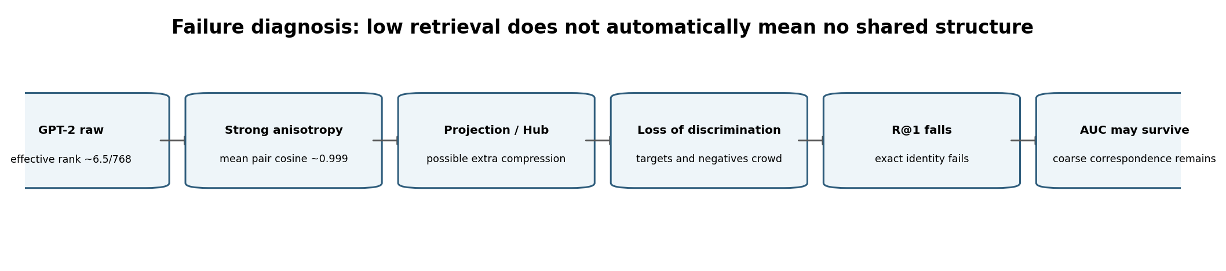
The supplied GPT-2 diagnostic is striking: nominal width 768, effective rank about 6.5, and mean pair cosine about +0.999. A wide nominal embedding can therefore behave as a very low-dimensional cone. That geometry can preserve coarse information yet be poor for cosine retrieval.
Diagnostic | Meaning | Test | Typical symptom
Anisotropy | Many vectors share similar global direction | mean pair cosine / spectrum | high cosine even for unrelated items
Effective rank | Few independent directions carry most signal | SVD singular values | 768 nominal dimensions can behave like ~6.5 useful directions
Hubness | Some candidates become nearest neighbours for many queries | k-occurrence / NN frequency | same few targets repeatedly retrieved
Arm collapse | Pair-specific margins disappear | R@1 vs AUC + geometry diagnostics | exact retrieval fails while coarse AUC may remain

10. HUB_DIM - What We Tested and What the Width Means
STATUS | METHODOLOGY USED; G1 operational Hub width = 512
TEST USED IN OUR PROJECT | SVD-prefix / HUB_DIM sweep using retention, rows-per-dimension and transfer performance.
WHAT IT ESTABLISHES | Balances information bottleneck against statistical underpowering.
CAT-CHAIR EXAMPLE | A too-small Hub may merge cat-chair with cat-sofa; a too-large Hub may fit unstable directions given only 8,533 fitting rows.

Methodological flow: build SVD once -> take first 256 / 512 / 768 / 1024 / ... components -> measure reconstruction/retention -> check N/HUB_DIM -> refit/evaluate transfer -> choose the largest useful dimension supported by data. The supplied methodology uses N/HUB_DIM >= 5 as a practical support criterion.

11. Tests Not Yet Established by the Supplied 7-Space Results
To keep the report scientifically clean, the following should not be presented as completed 7-space findings unless you run them. They are valuable because they fill specific gaps left by the performed tests.
Open methodological item | Next test | Why it matters
Pairwise distance-rank agreement | Spearman / rank correlation | Would test shared ordering beyond immediate kNN.
Near-isometry | PCA + Orthogonal Procrustes | Would test whether spaces differ mostly by rotation/reflection.
Explicit shared subspace | CCA spectrum | Would quantify correlated shared directions plus private dimensions.
Architecture/modality causal explanation | Group 21 pairs by same/different modality, architecture, objective | Would distinguish model-induced similarity from world-induced relational structure.

12. Full Methodological Flow - From Platonic Hypothesis to Engineering Decision
Stage | Test/action | Cat-chair question
1. Same world / referent | Use aligned COCO image-caption rows. | cat-chair image and cat-chair sentence share row i.
2. Local invariant | Run kNN overlap + scale/chance. | Do image and text agree on the cat-chair neighbourhood?
3. Global structure | Run CKA. | Does agreement extend beyond immediate neighbours?
4. Export direction | Fit Ridge / direct map. | Can image coordinates predict BGE coordinates?
5. Shared coordinate system | Build G1 Hub + W_k maps. | Can all encoders express item i as h_i in H_512?
6. Functional reuse | Freeze Hub->BGE head and transfer across arms. | Does a head trained on small still work on base/large?
7. Operational identity | Evaluate R@1/R@K. | Does the cat-chair target win among all candidates?
8. Residual signal | Evaluate Verification AUC. | If top-1 fails, is the true pair still usually above random?
9. Diagnose failure | SVD/rank/anisotropy/hubness. | Did the geometry collapse rather than the shared structure disappear?
10. Interpret Platonic strength | Compare cross-modal vs within-family agreement. | Cross-modal local invariants strengthen the world-induced explanation.

13. One Paragraph You Can Use in the Final Report
Suggested methodological wording
We treat each encoder as a coordinate chart over the same set of aligned semantic items rather than assuming identical vectors. For the example item represented by an image of a cat sitting on a chair and the caption "A cat is sitting on a chair.", we first test coordinate-free local structure using nearest-neighbour overlap and its enrichment over chance across k. We then compare global representational geometry with CKA, test directional exportability with linear maps, and construct a 512-dimensional shared Hub by PCA/SVD over standardized aligned representations. The Hub is validated functionally by freezing a Hub-to-BGE head trained on one DINO arm and measuring transfer from unseen DINO arms. Exact pair recovery is evaluated with R@K, while Verification AUC, effective rank, anisotropy and hubness diagnose cases where coarse correspondence survives but retrieval-level discrimination collapses. Local cross-modal agreement remains compatible with the Platonic Representation Hypothesis because the hypothesis concerns shared relational invariants of the underlying world, not identity of global coordinates or Euclidean metrics.

14. Final Interpretation Ladder
Observed pattern | Scientific claim supported | Platonic reading
kNN above chance only | Partial shared local topology | Weak but genuine Platonic-compatible evidence.
kNN + CKA high | Local and broader relational geometry shared | Stronger structural convergence.
Ridge export works | Structure is linearly accessible across spaces | Shared information is operationally transferable.
Shared Hub + frozen-head transfer works | Common coordinates have cross-encoder functional meaning | Strong evidence for reusable shared representation.
Procrustes also works | Near-isometry | Very strong: almost same geometry, different coordinates.
AUC survives while R@1 fails | Coarse shared structure but insufficient local discrimination | Do not interpret as proof of no convergence.
Only within-family agreement survives | Architecture/modality explanation dominates | Platonic claim weakens.
Cross-modal / cross-architecture invariants survive | World-induced structure harder to dismiss | Platonic interpretation strengthens.

Methodological synthesis based on the supplied Shared-Hub and Observer/Platonic documents, plus the local-topology figures supplied in this conversation.
15. Compact End-to-End Evidence Flow
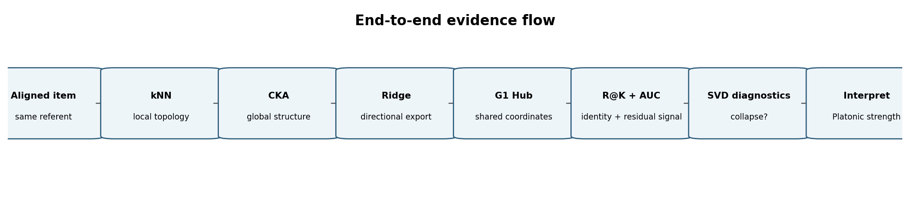
The sequence separates increasingly strong claims: local adjacency can support a Platonic-compatible shared manifold without implying global metric identity; CKA asks whether structure is broader; Ridge and the shared Hub ask whether it is operationally transferable; R@K/AUC separate exact identity from coarse correspondence; and SVD/anisotropy/hubness diagnostics prevent a collapsed representation from being mistaken for evidence against shared structure.

